
Year 8
French
Knowledge
Organiser
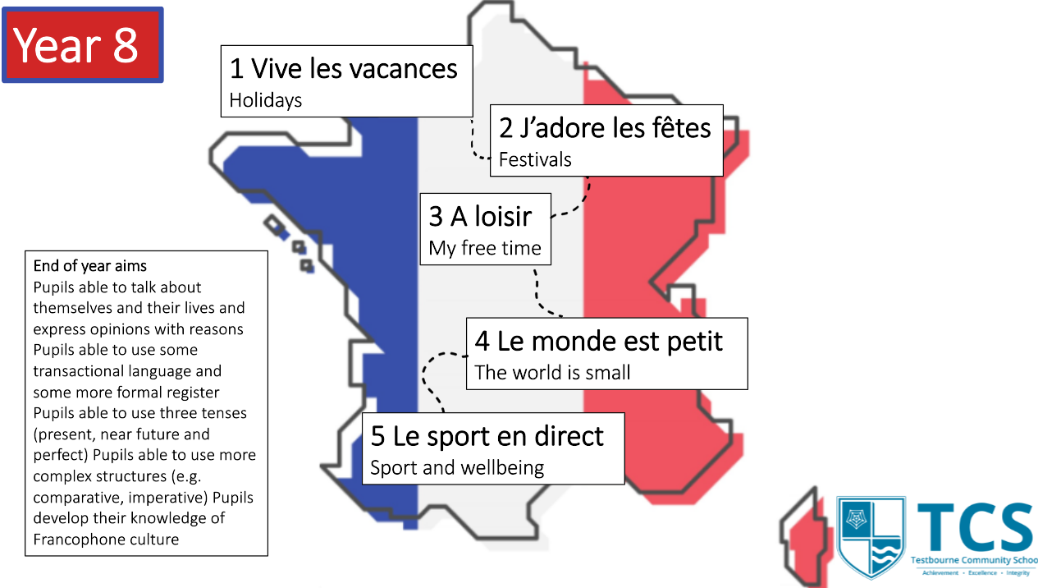

Croissant 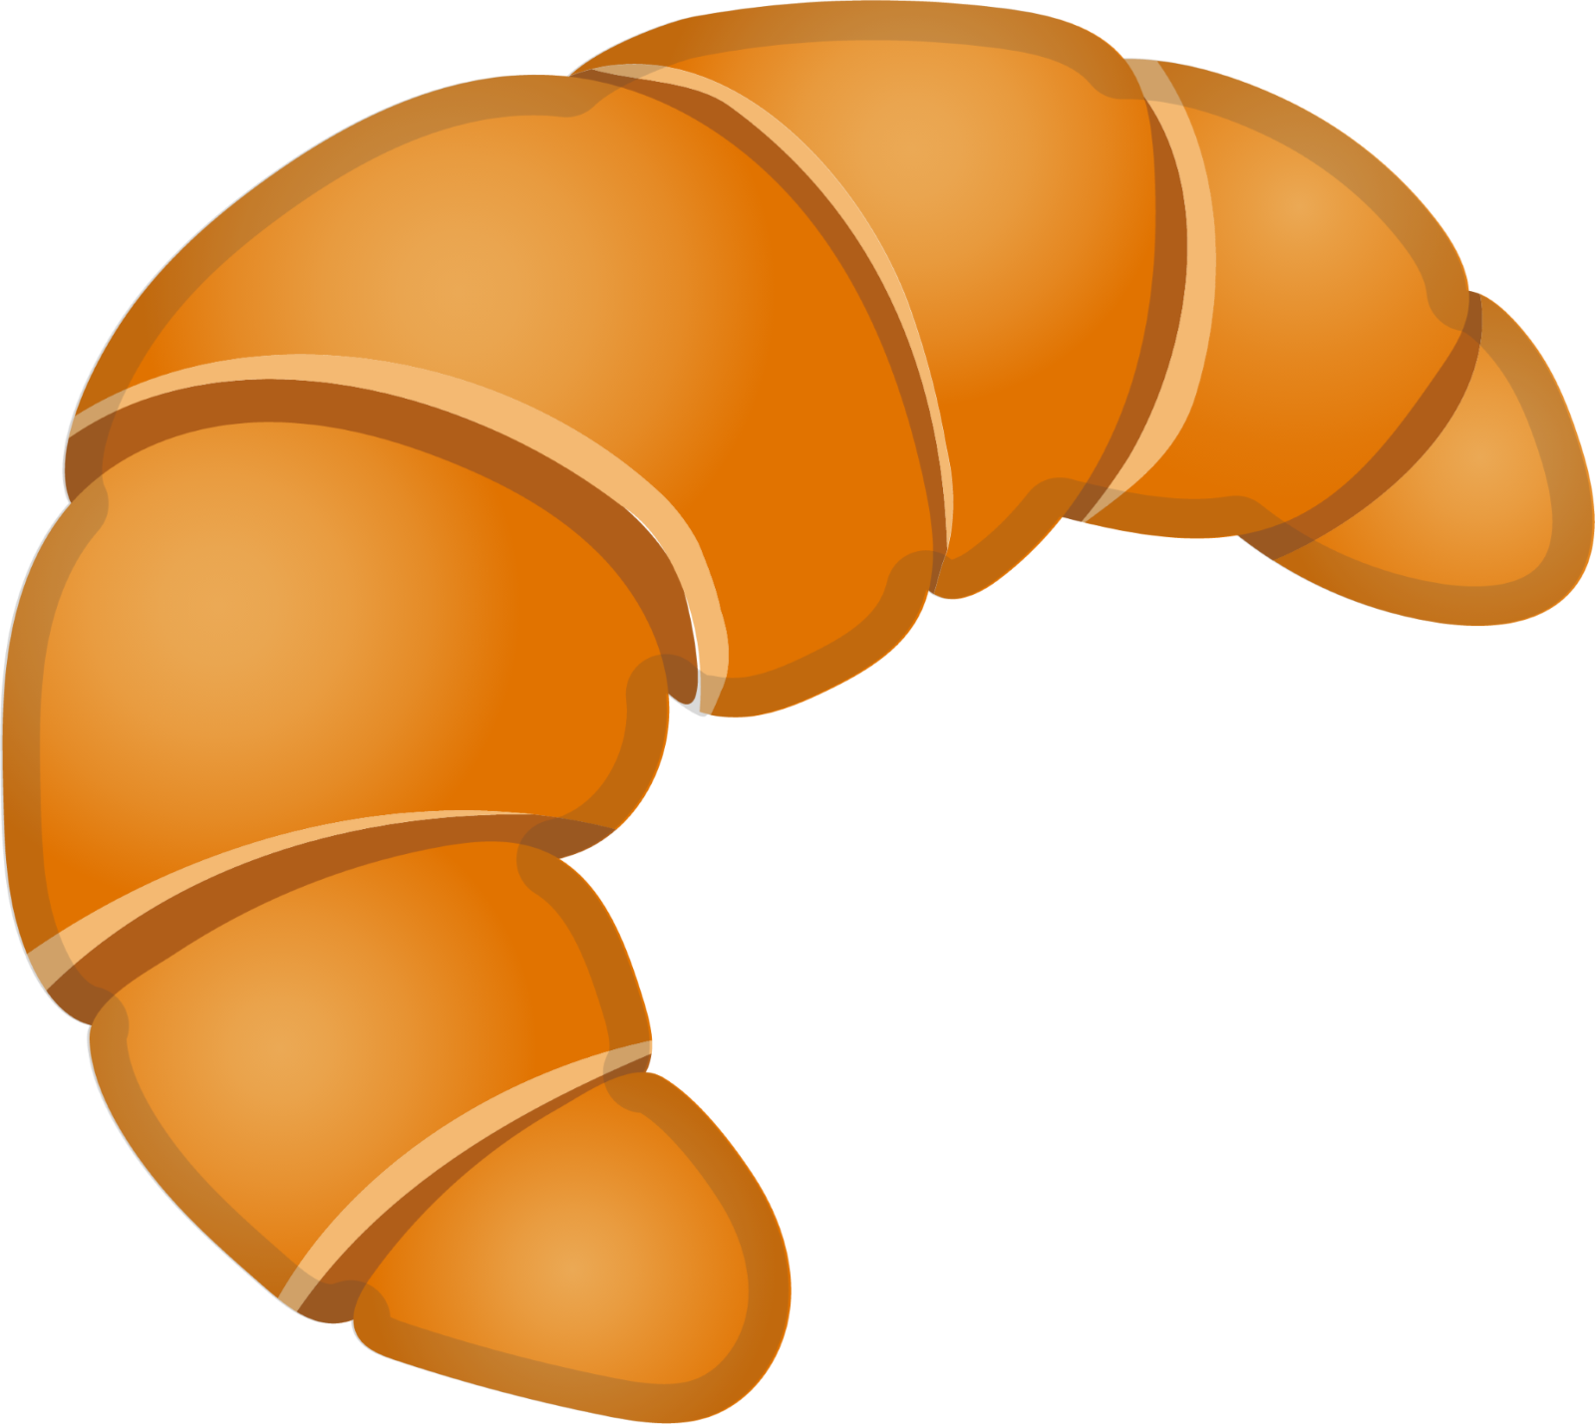

 | What is it? | Examples in French
Connectives | Words that link two short sentences together. | et – and  mais – but  cependant – however  en plus – in addition
Reasons | Saying why you have an opinion or why you do something. | parce que = because  c’est – it is  ce n’est pas – it is not
Opinions | Saying you like or dislike something or using an adjective to express opinion. | Je pense que – I think that  J’adore – I love  J’aime – I like  Je n’aime pas – I don’t like  Je déteste– I hate
Intensifiers | Increase complexity with these throughout you writing. Words such as very/quite/more/less/a little | très = very  beaucoup = a lot  assez = quite  un peu = a little
Sequencers | Use this to narrate events in your extended writing and to give time frames. | normalement - normally  hier – yesterday  la semaine dernière – last week  demain – tomorrow  la semaine prochaine – next week
Sparkles | Use these to show high levels of complexity to your writing. | plus…que = more than  moins…que = less than  aussi… que = as…as
Adjectives | Used to describe a noun, you should aim for a variety of these (not just amusant/intéressant/ennuyeux) | fascinant(e) = fascinating  bruyant(e) = loud  silencieux(euse) = quiet  agréable = agreable  désagréable = unpleasant  passionnant(e) = exciting  dégoutant(e)= disgusting
Negatives | Phrases such as never/no longer/neither…nor etc | ne… jamais = never  ne…. plus = no longer  ne…pas = not
Tenses | Use these to add complexity. Remember to use appropriate time indicators to ensure that it is clear when you are talking about. | Past – Hier, il y a deux ans, la semaine dernière…  Present – Normalement, de temps en temps, parfois…  Future – la semaine prochaine, l’été prochain…  Past  j’ai mangé = I ate  je suis allé(e) = I went  c’était = it was  Present  j’ai = I have  je fais = I do  je suis = I am  il y a = there is  Future  Je vais aller = I am going to go  je voudrais/ j’aimerais = I would like

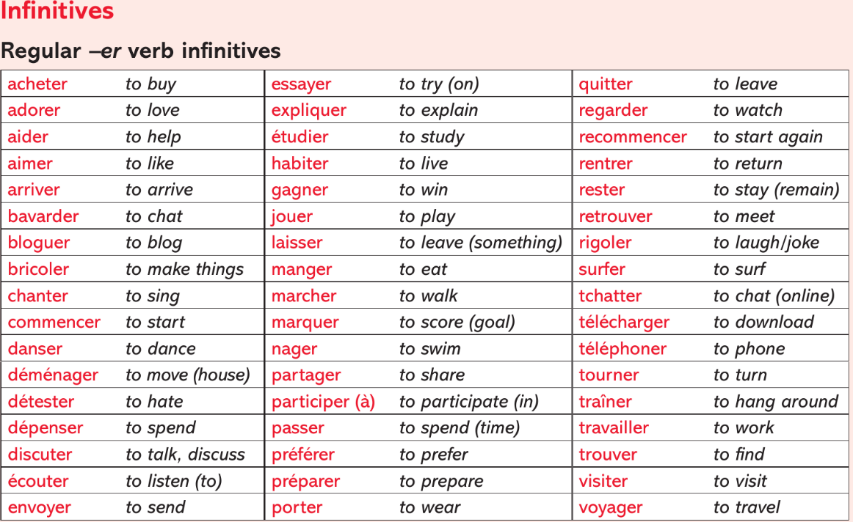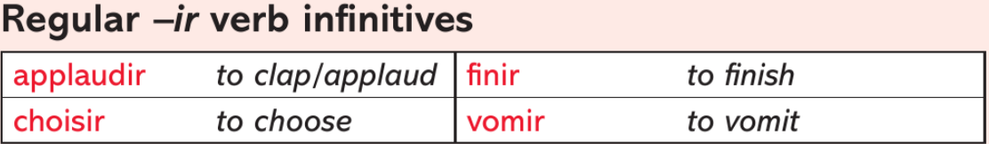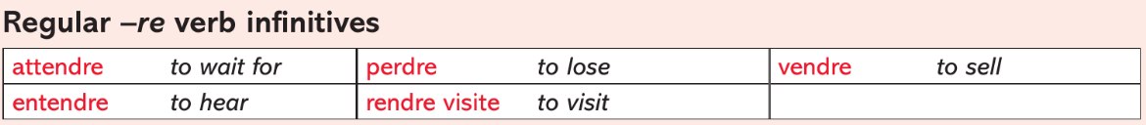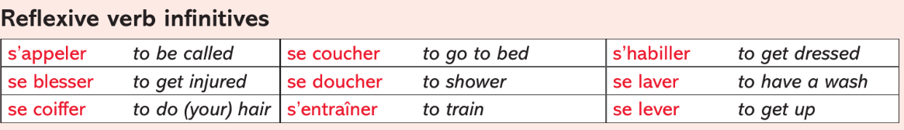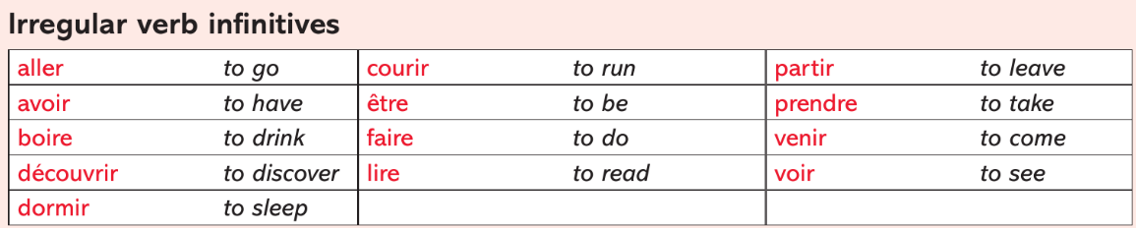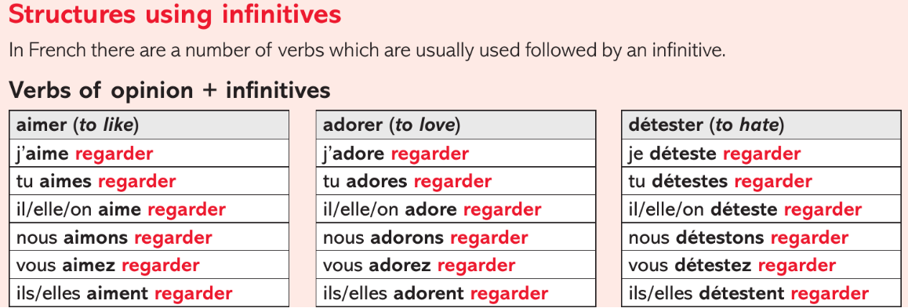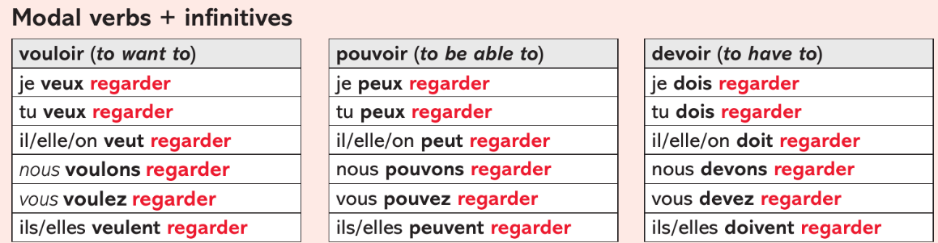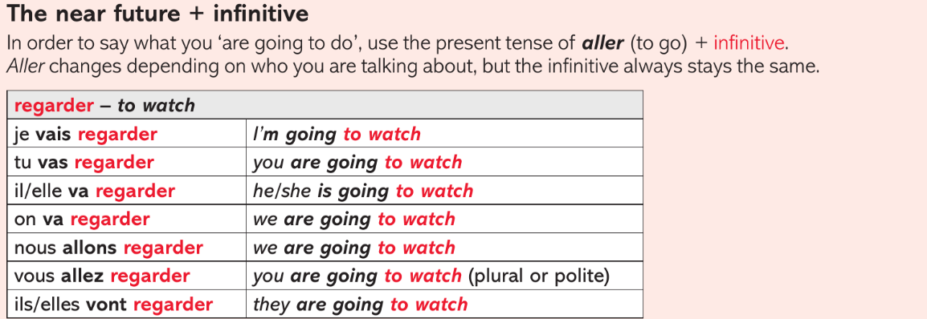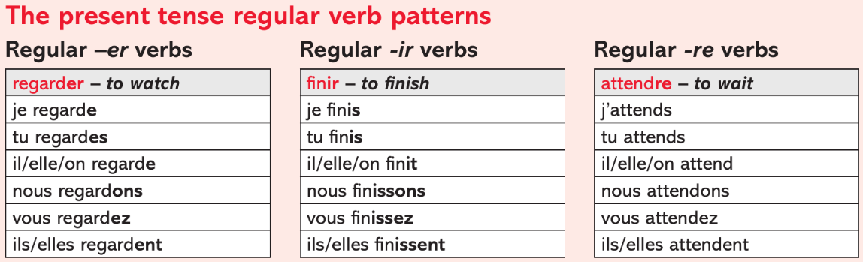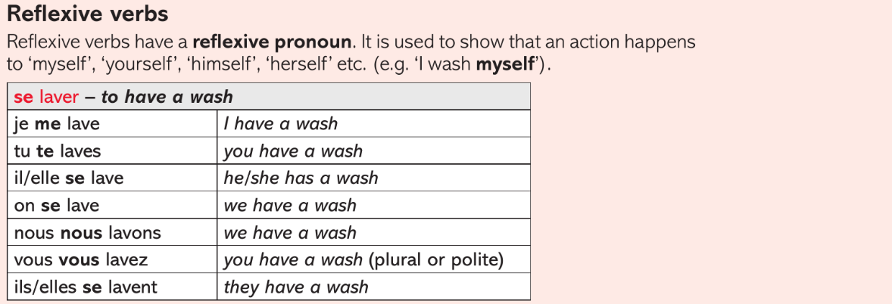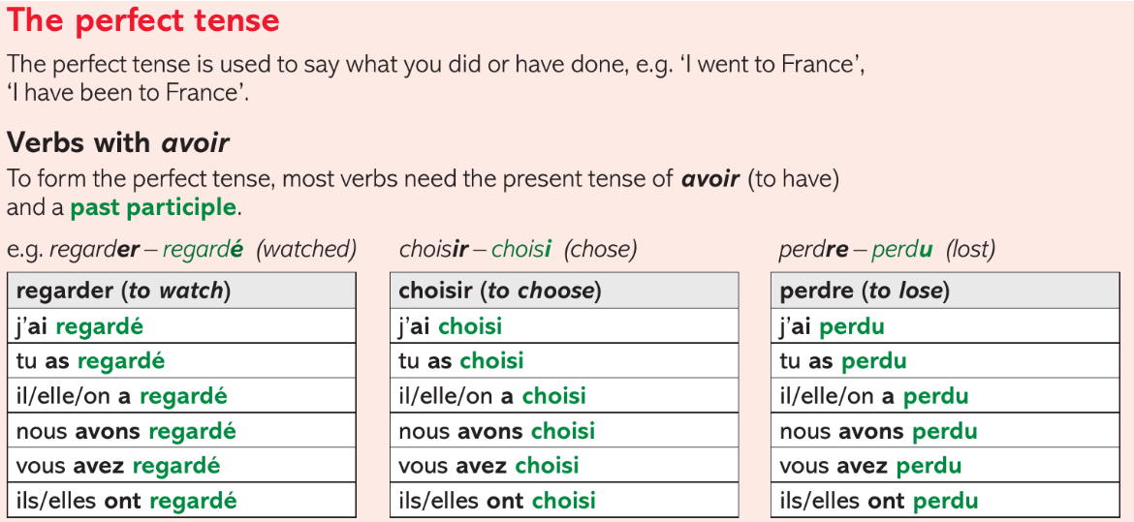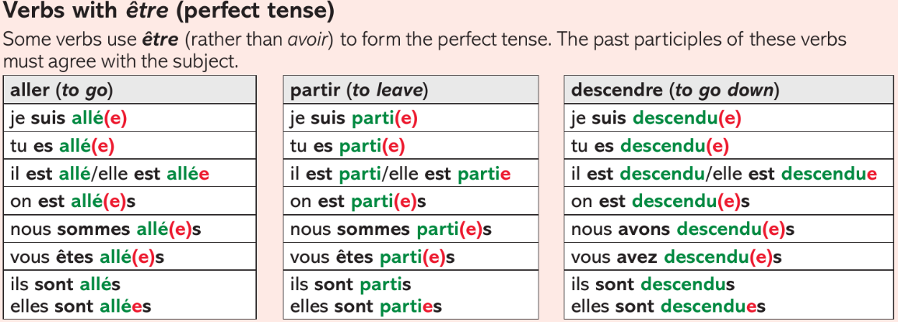

Module 1 – Vive les vacances – I can...
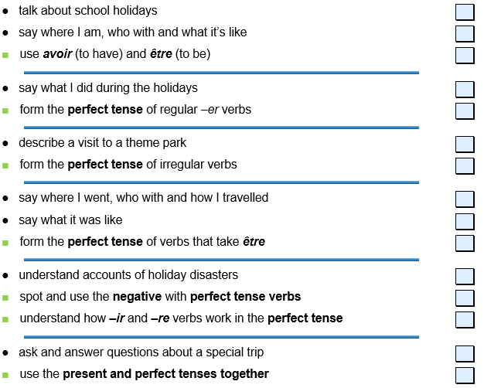

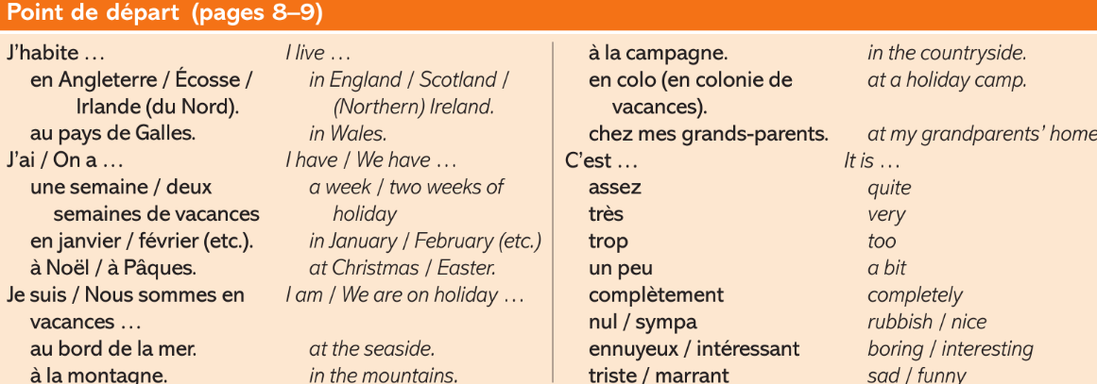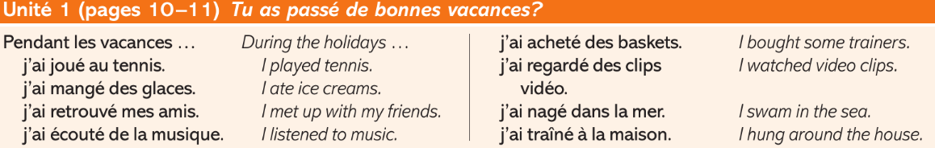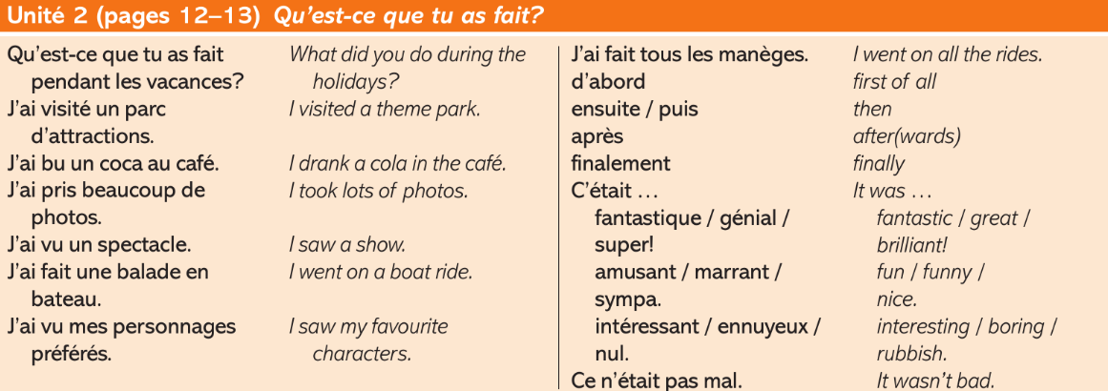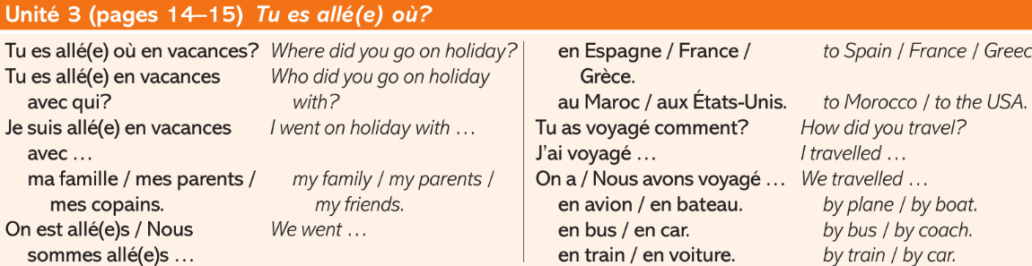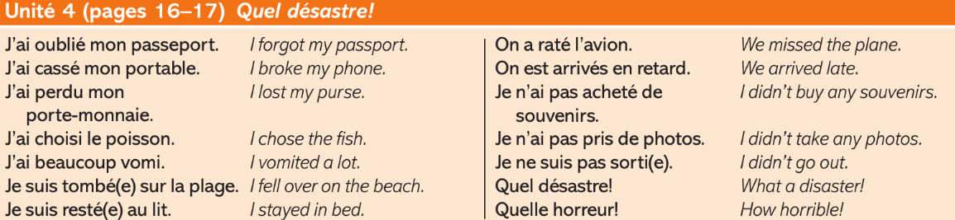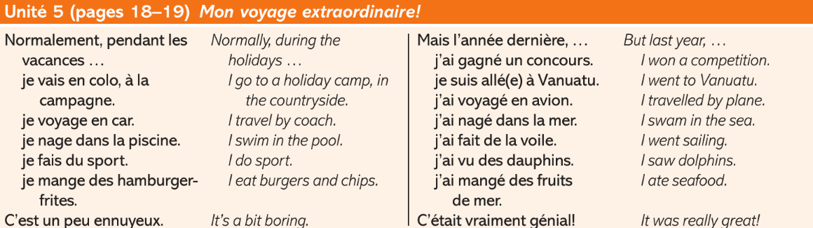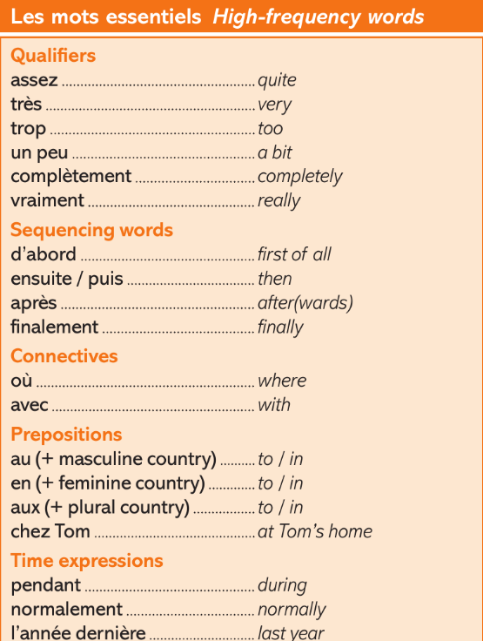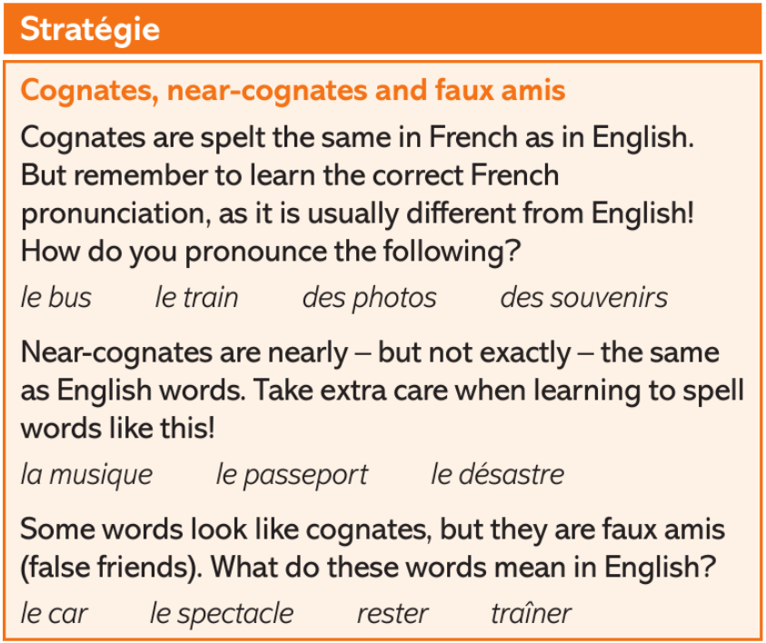

Module 2 – J’adore les fêtes - I can...
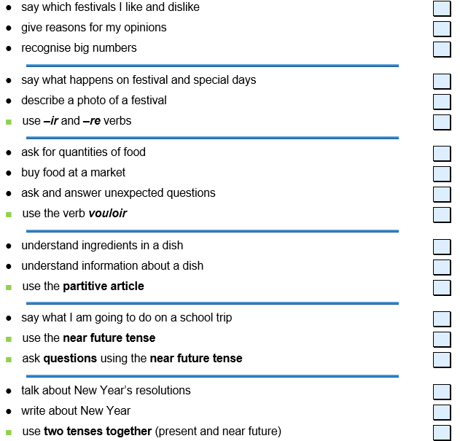

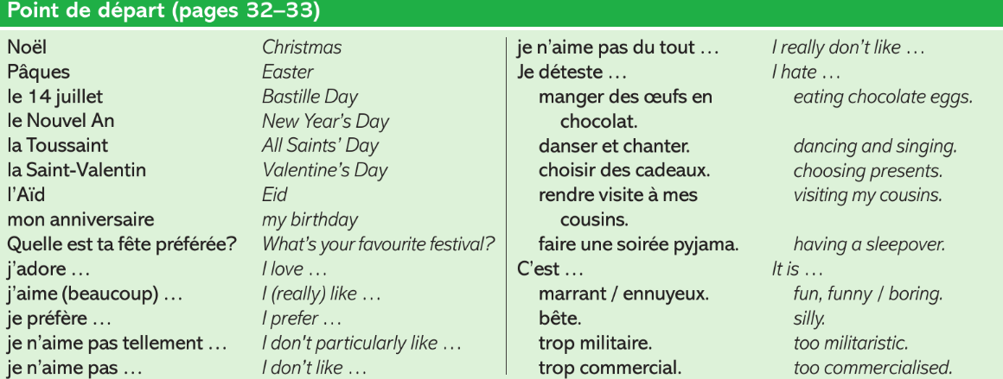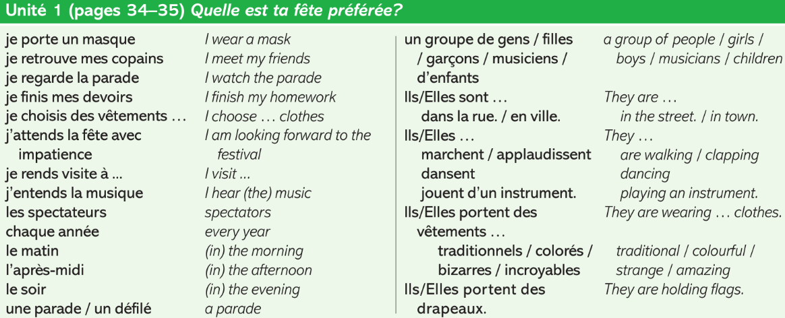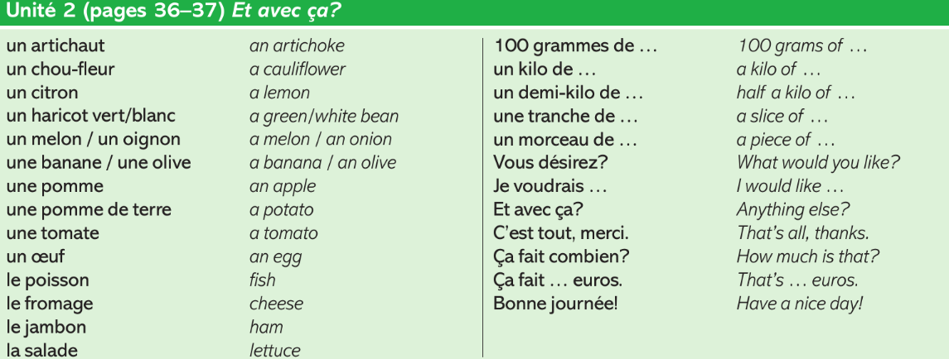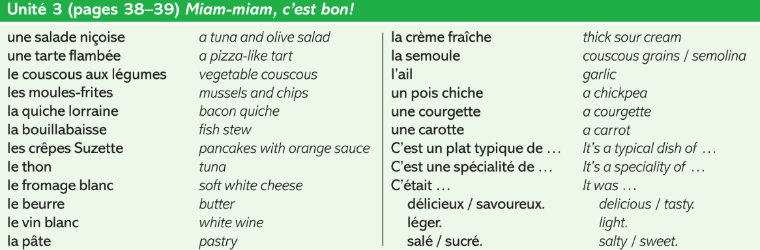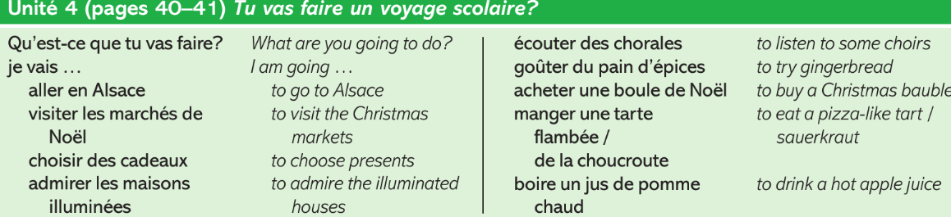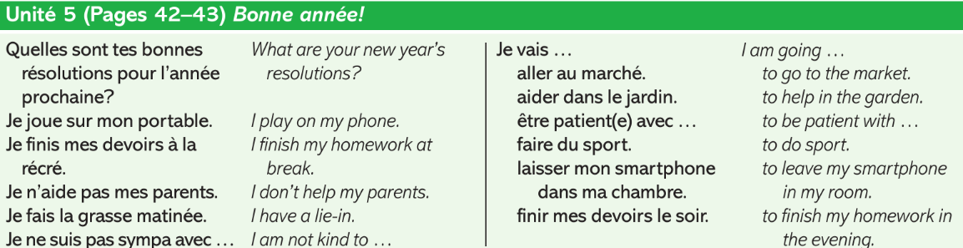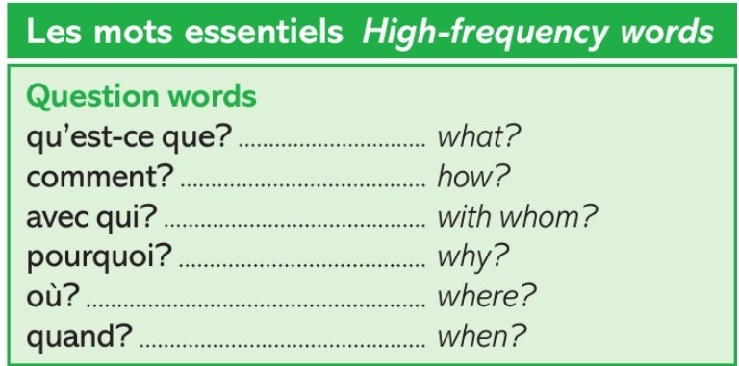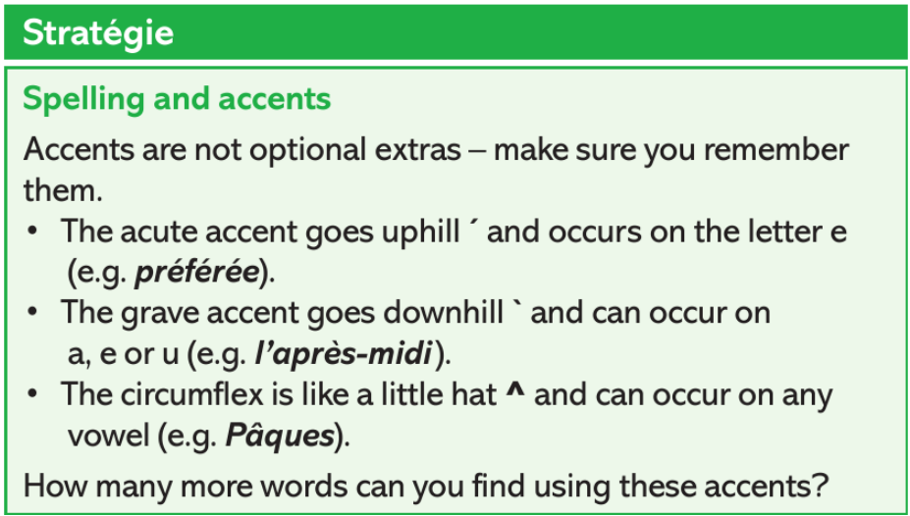

Module 3 - À loisir – I can...
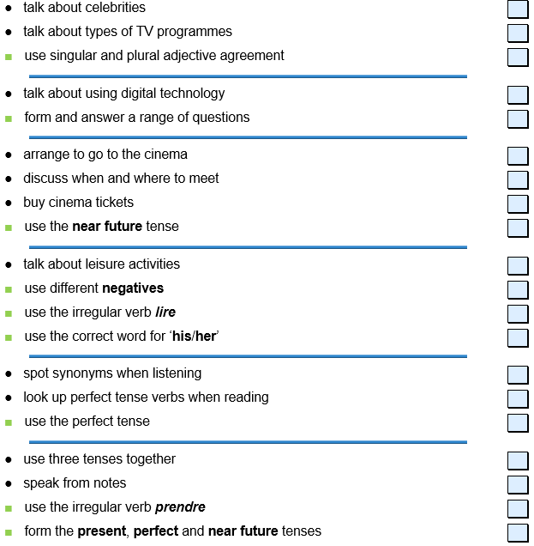

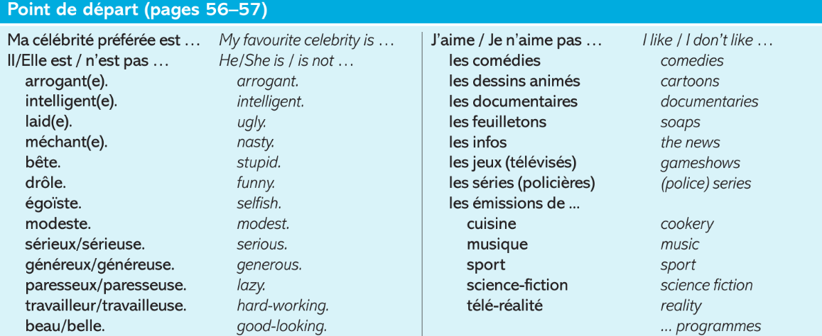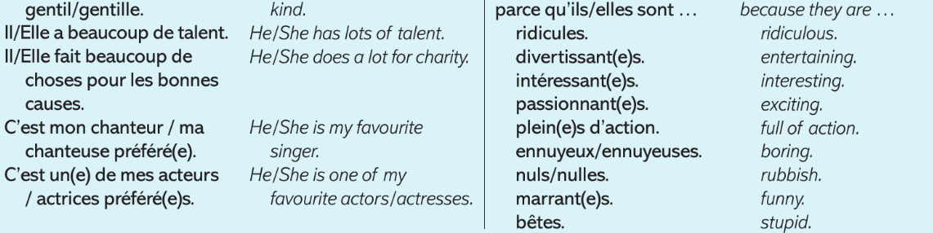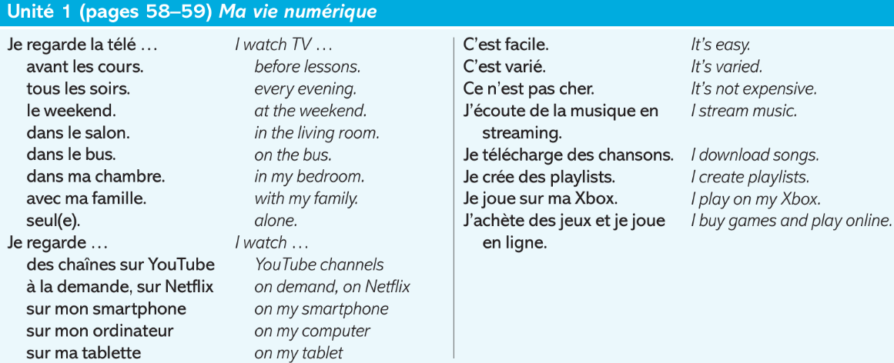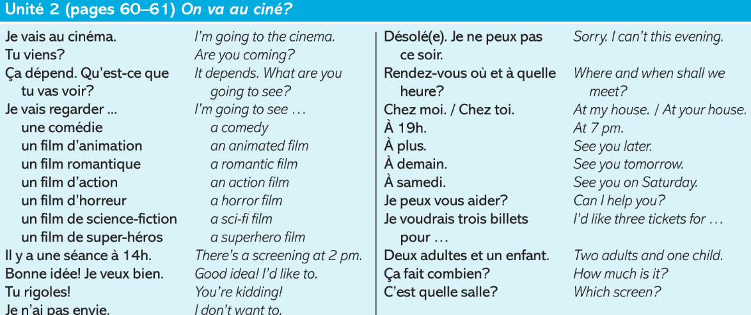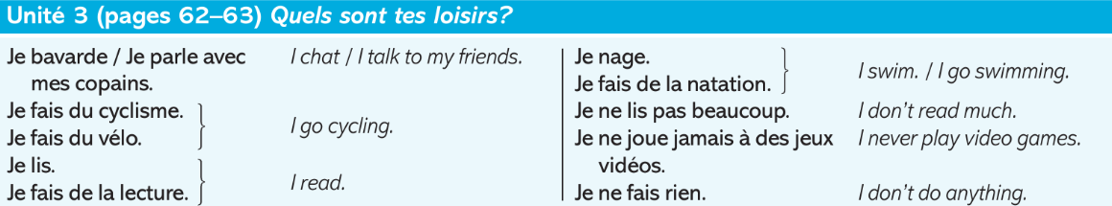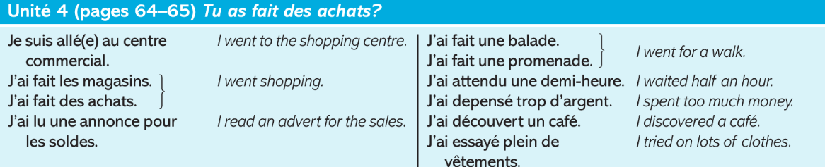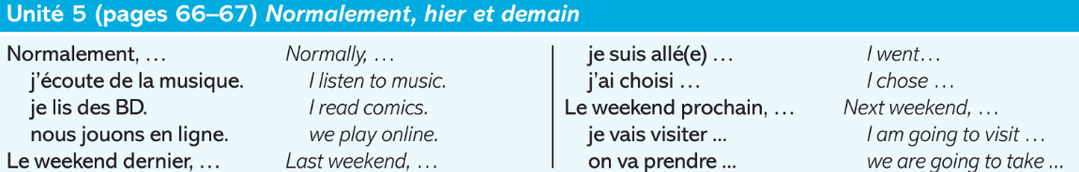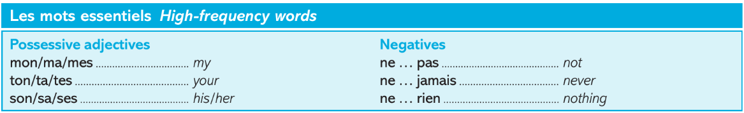

Module 4 – Le monde est petit – I can...
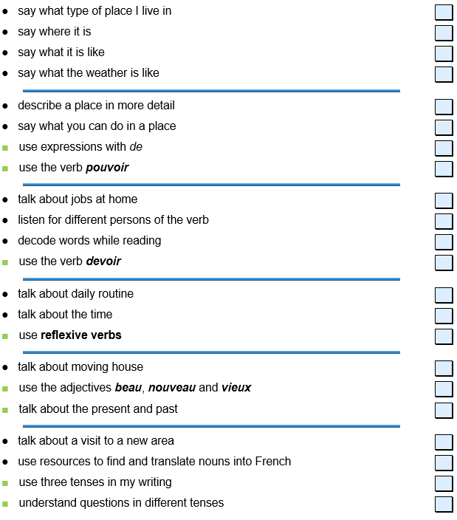

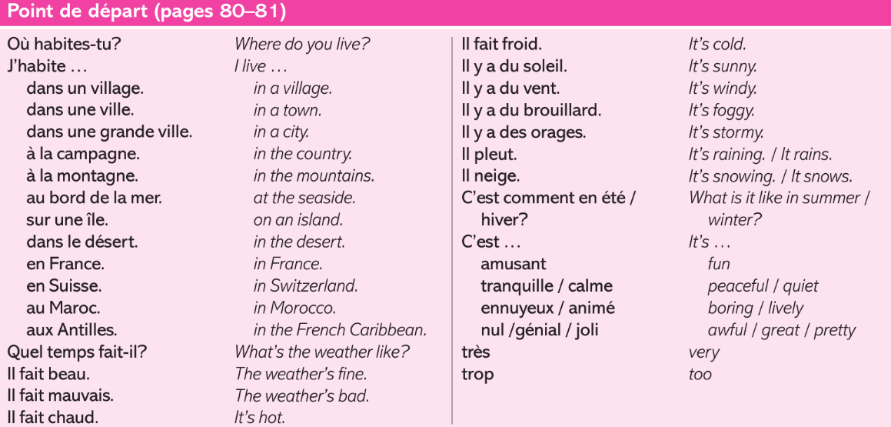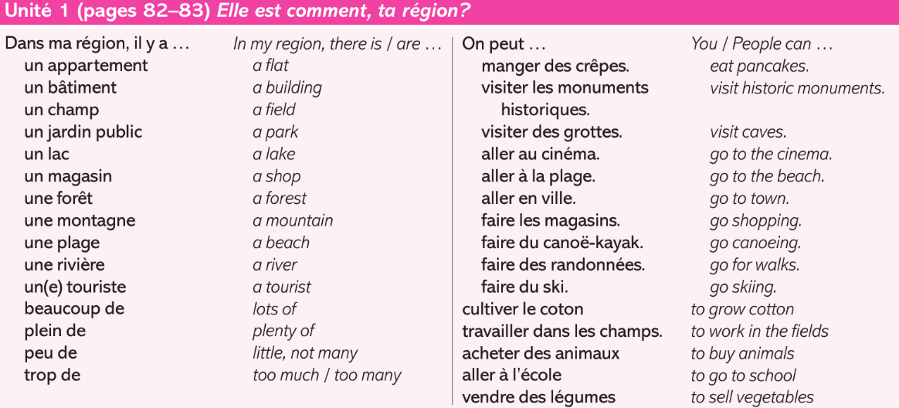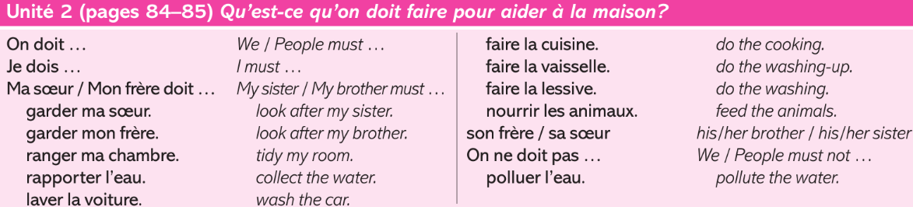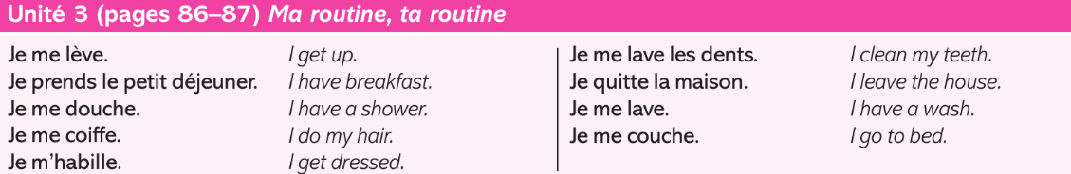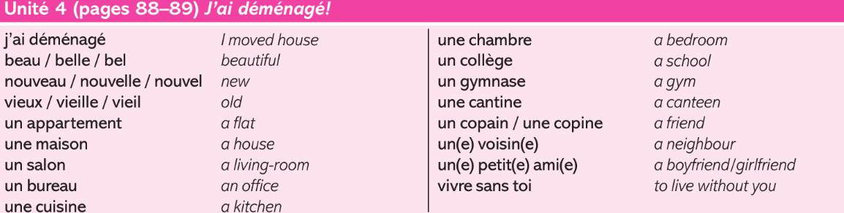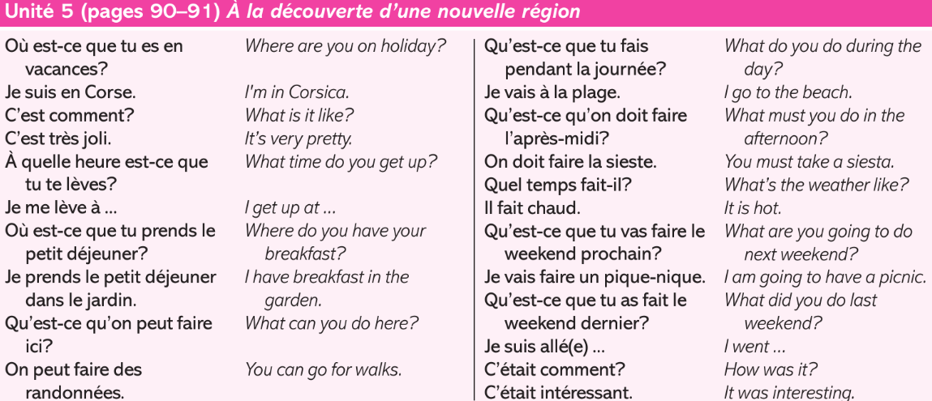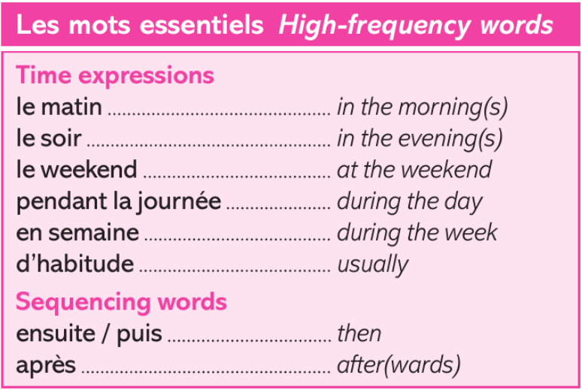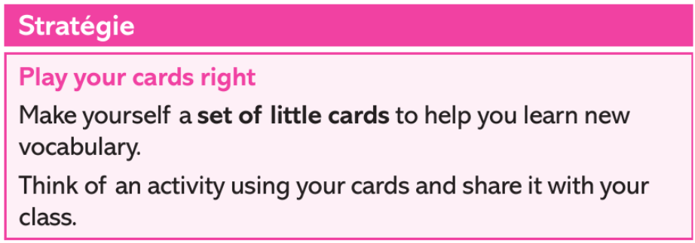

Module 5 – Le sport en direct – I can...
