

**Year 8**

**Spanish**

**Knowledge**

**Organiser**

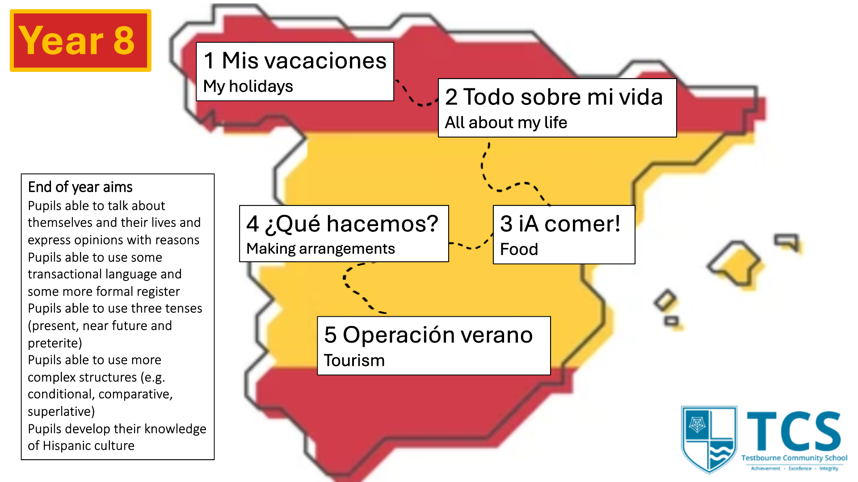

**Avocados** 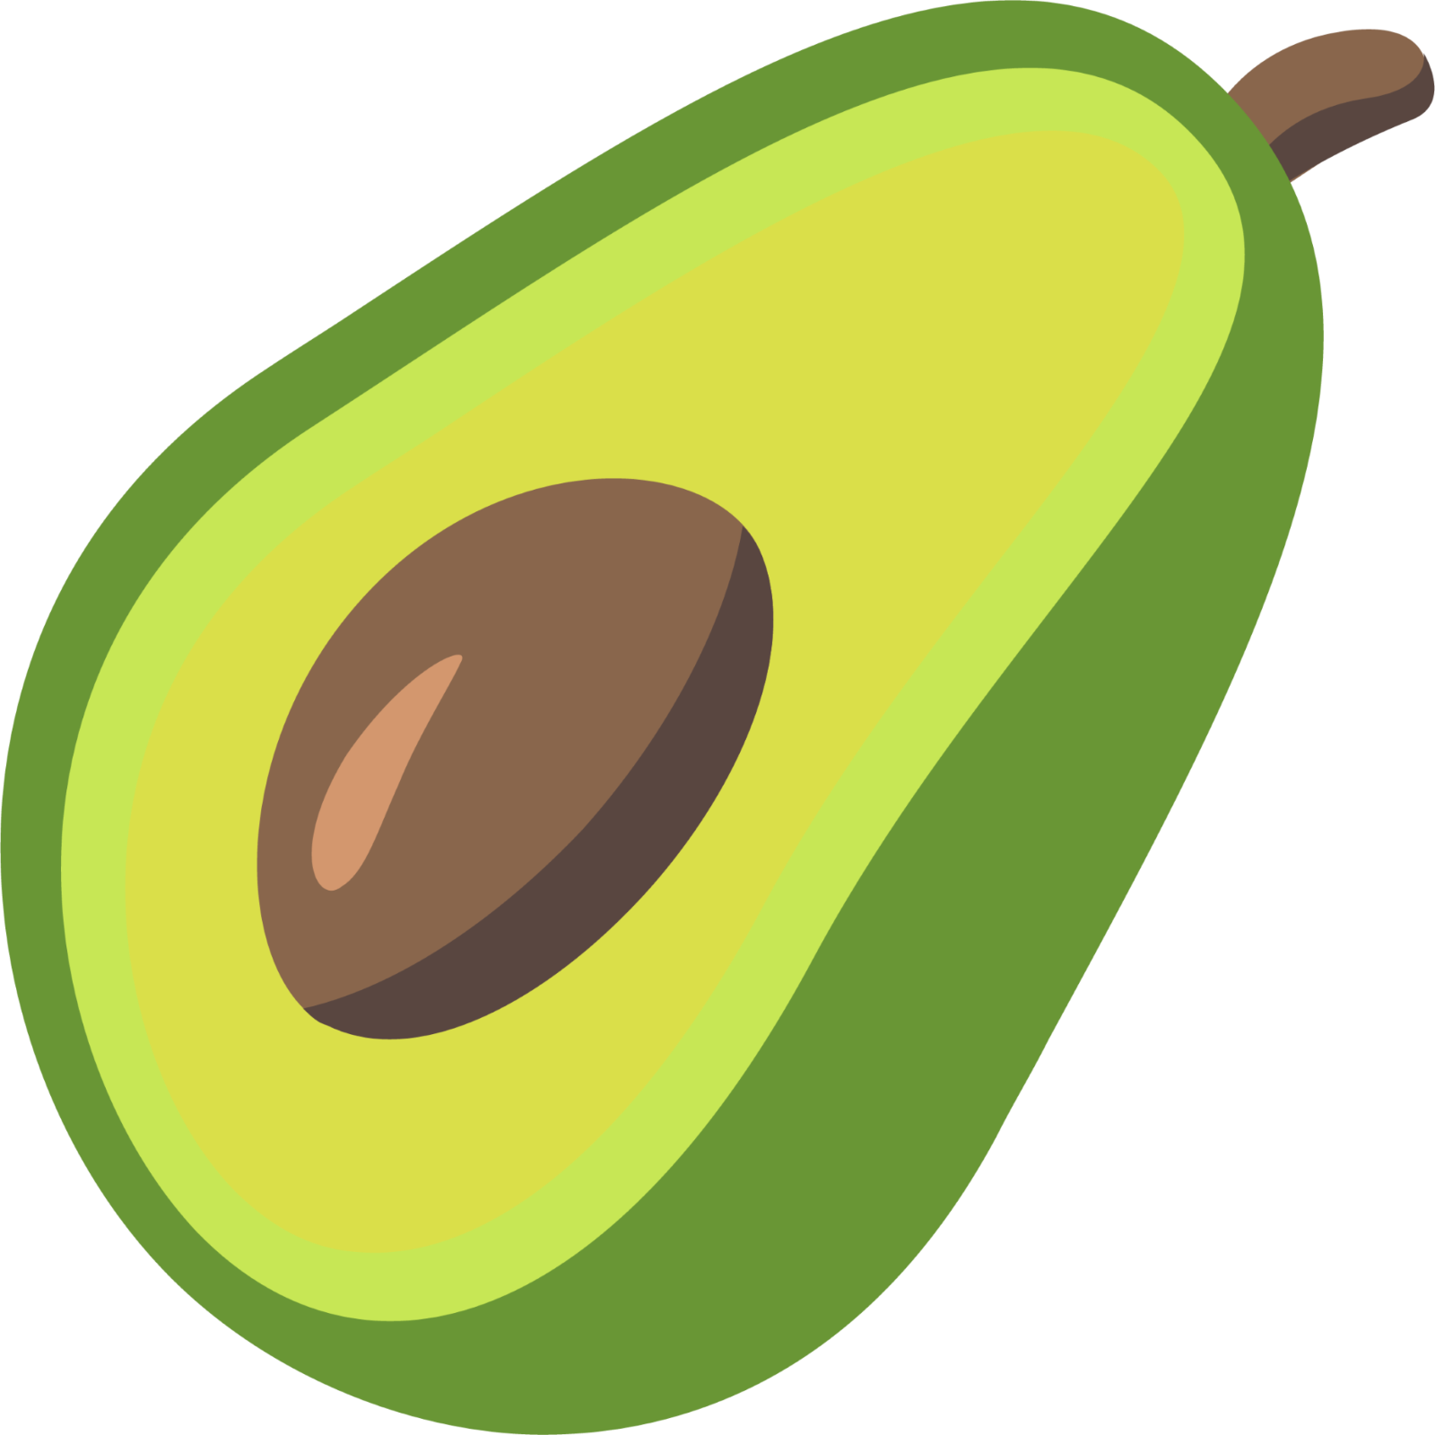

|  |  |  |
| --- | --- | --- |
|  | **What is it?** | **Examples in Spanish** |
| **Adjectives** | Used to describe a noun, you should aim for a variety of these (not just divertido/interesante/aburrido) | Fascinante = fascinating  Ruidoso = loud  Tranquilo = calm  Agradable = agreable  Desagradable = unpleasant  Apasionate = exciting  Asqueroso = disgusting |
| **Verbs/Tenses** | Use these to add complexity.  Remember to use appropriate time indicators to ensure that it is clear when you are talking about. | Past – Ayer, hace dos años, la semana pasada  Present – Normalmente, de vez en cuando, a veces  Future – la semana que viene, el próximo verano  **Verb tenses**  Past  fui = I went  fue = it was  Present:  voy = I go  soy = I am  hay = there is/are  tengo = I have  Future:  voy a ir = I am going to go  va a ser = it is going to be |
| **Opinions** | Saying you like or dislike something or using an adjective to express opinion. | Pienso que – I think that  me encanta(n) – I love  me gusta(n) – I like  no me gusta(n) – I do not like  odio – I hate  Porque es – because it is |
| **Conjunctions** | Words that link two short sentences together. | y – and  pero - but  sin embargo – however  además – in addition |
| **Adverbs** | Words that add more detail to an adjective/adverbs of frequency tell us how often something is done | Siempre – always  A veces – sometimes  A menudo – often  Nunca - never |
| **Detail** | ncrease complexity with these throughout you writing.  Words such as very/quite/more/less/a little | Muy – very  Bastante – quite  Un poco – a bit |
| **Outstanding phrases** | Use these to show high levels of complexity to your writing. | más…que = more than  menos…que = less than  tan…como = as…as |
| **Sequencers** | Use this to narrate events in your extended writing and to give time frames. | normalmente - normally  ayer – yesterday  la semana pasada – last week  mañana – tomorrow  la semana que viene – next week |

**The present tense**

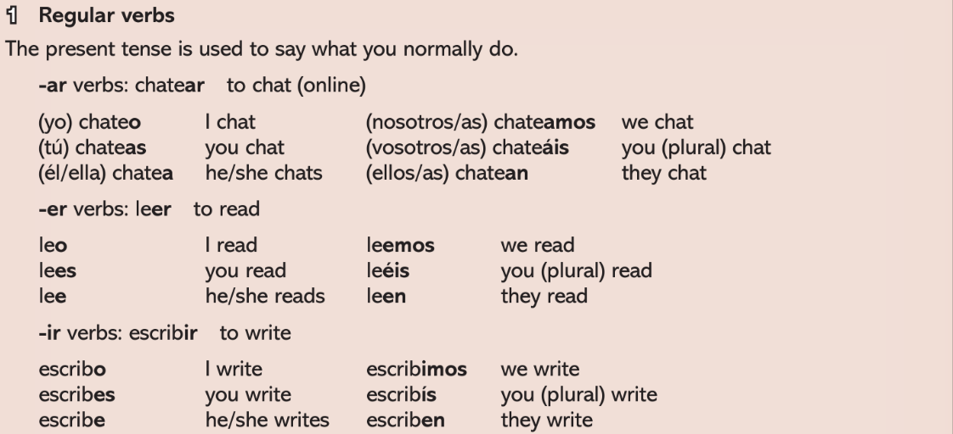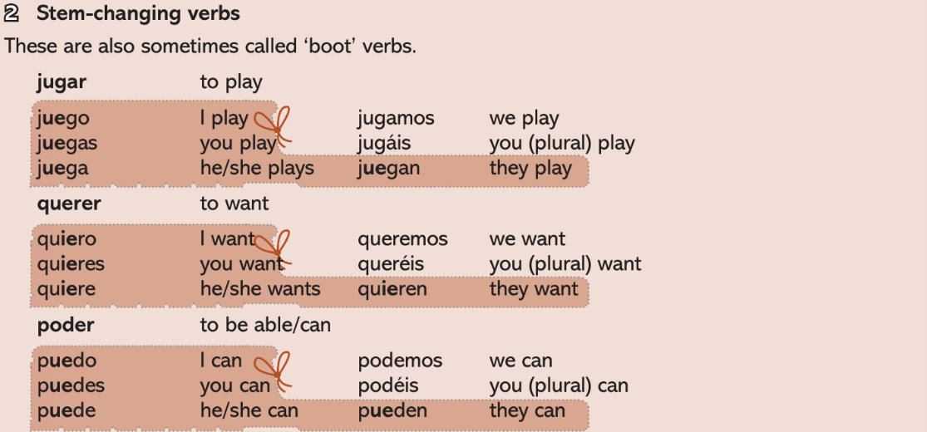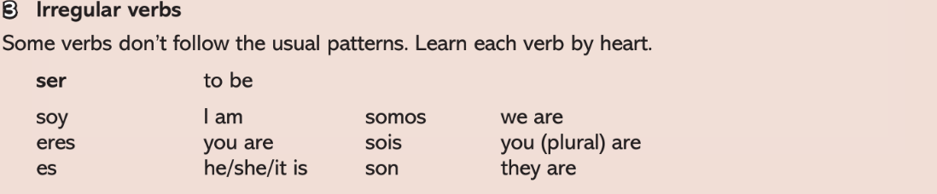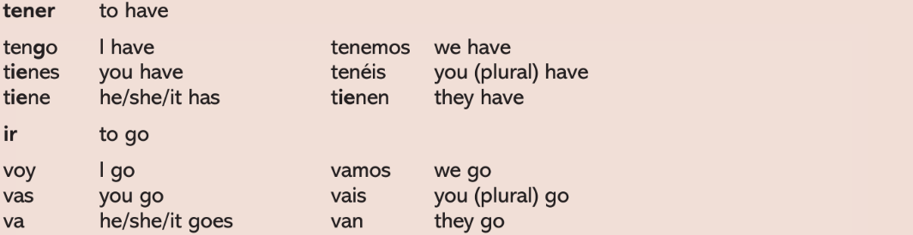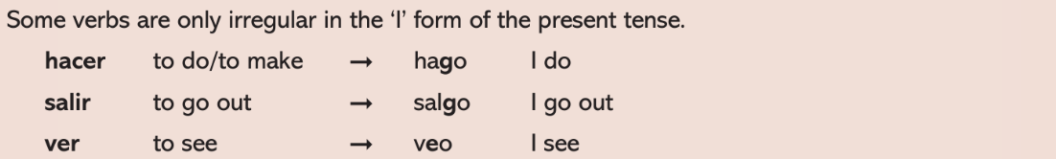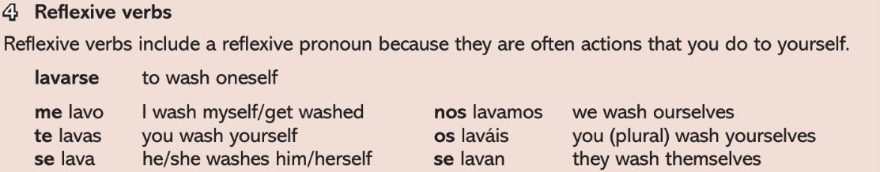

**The preterite (past) tense**

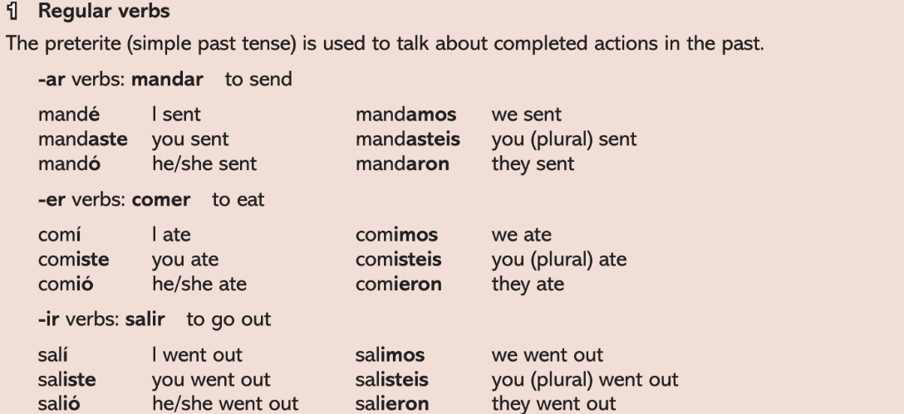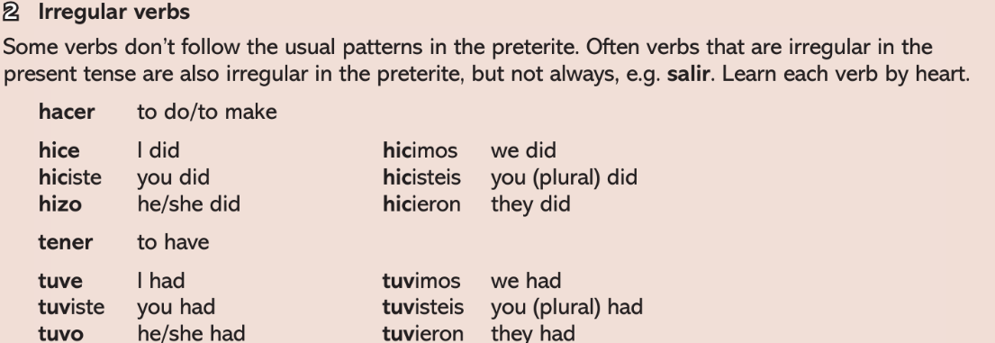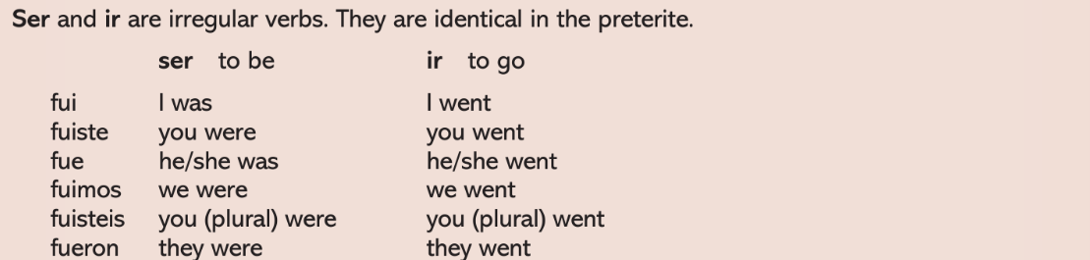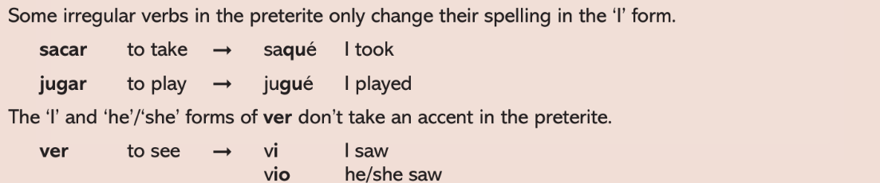

**The near future tense**

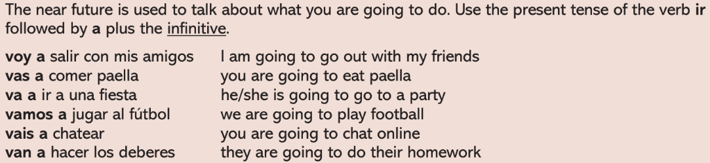

**Module 1 – De vacaciones – I can...**

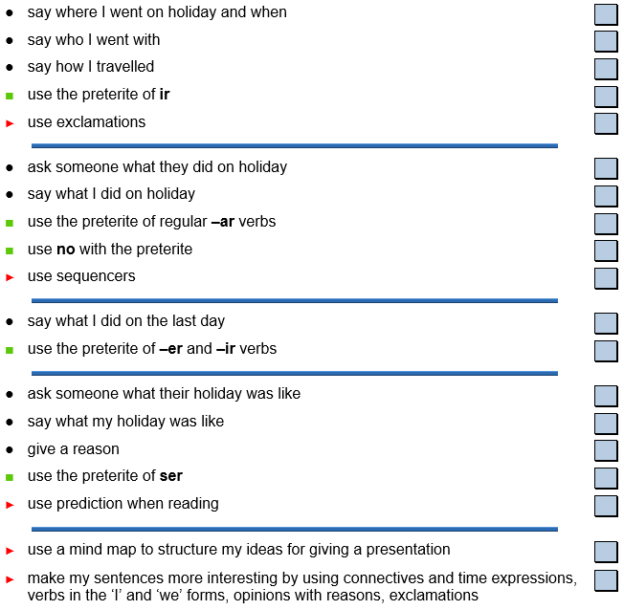

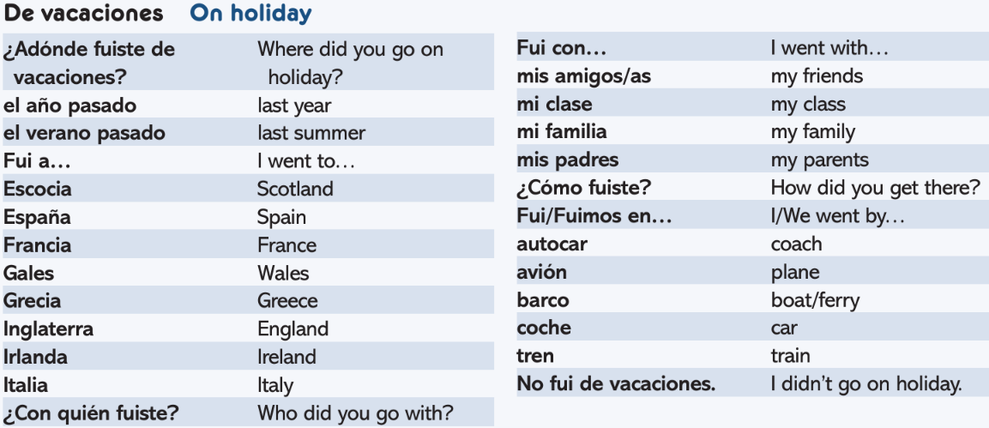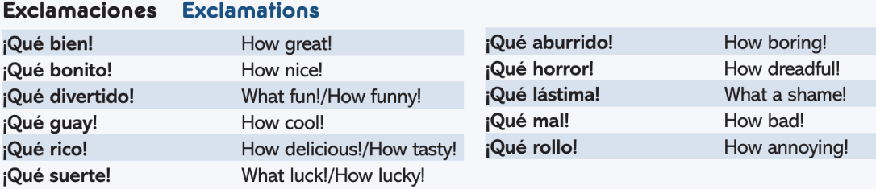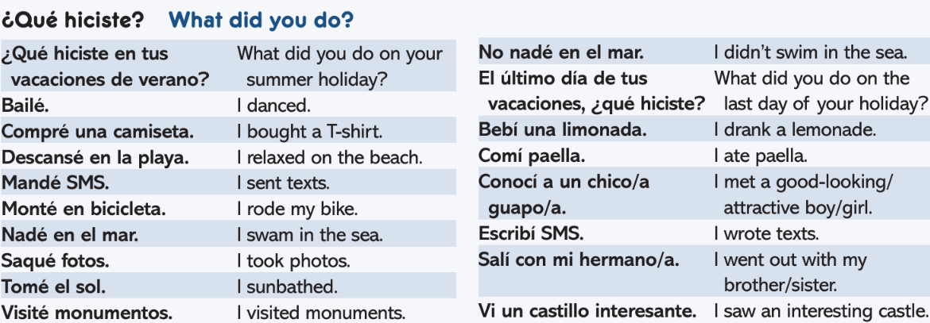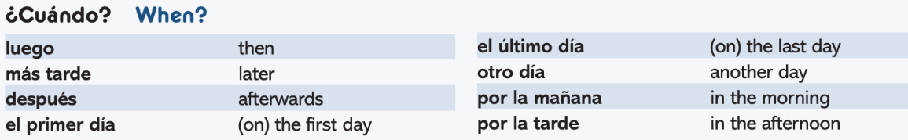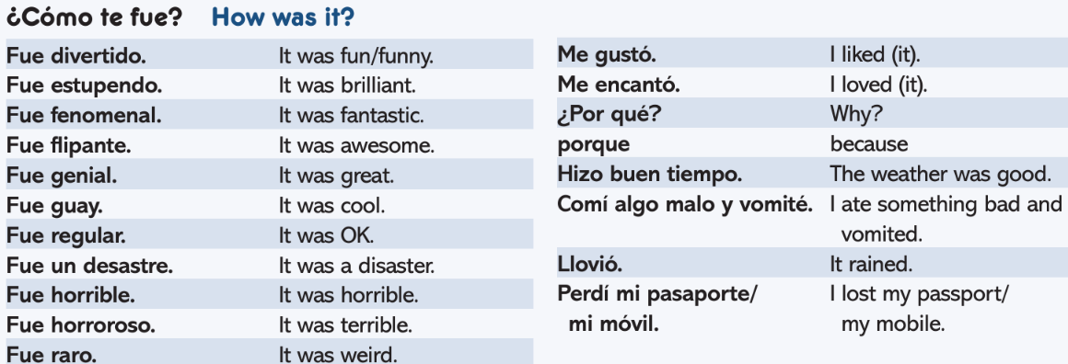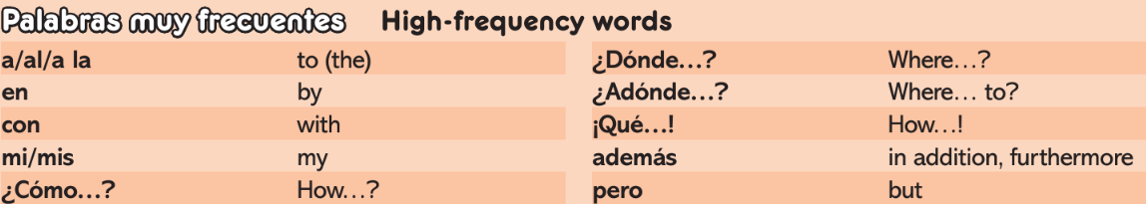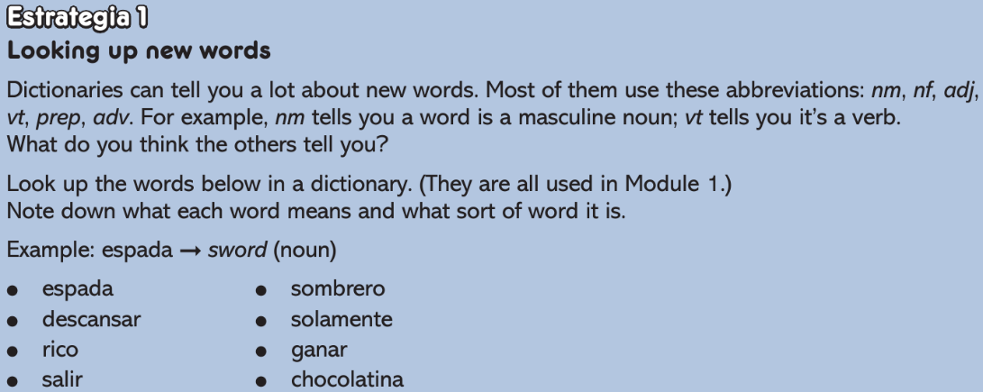

**Module 2 – Todo sobre mi vida – I can...**

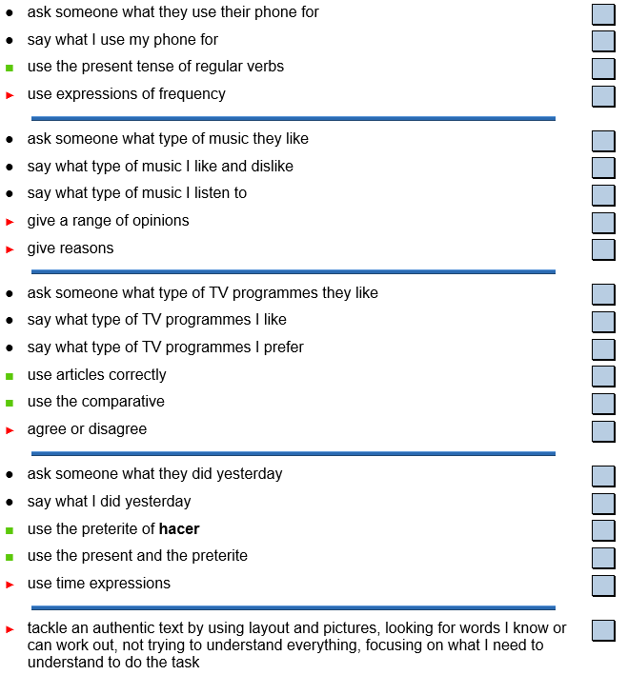

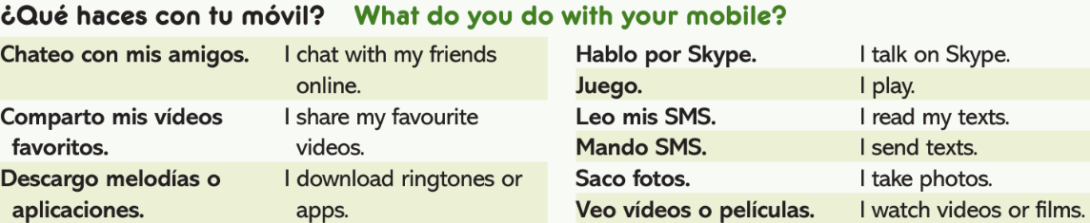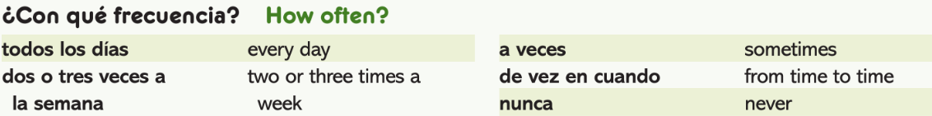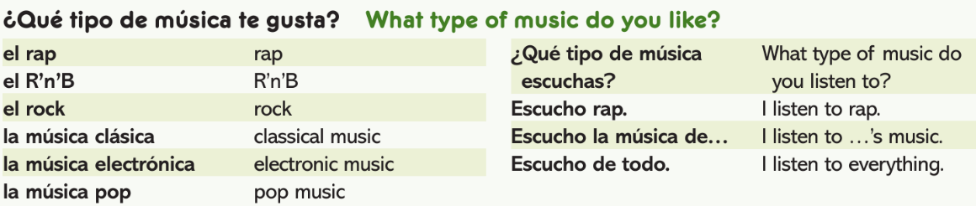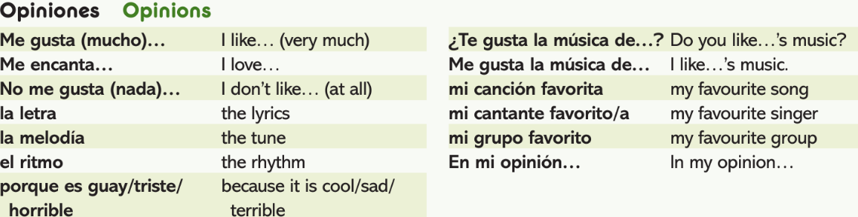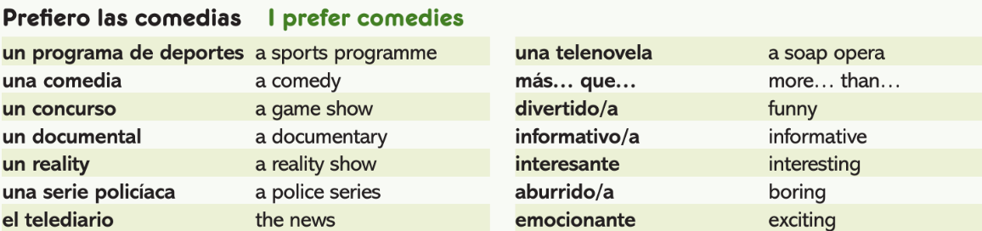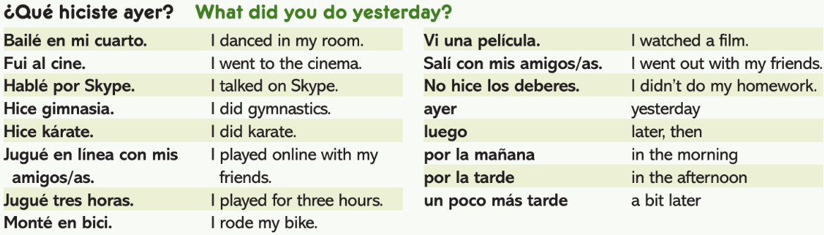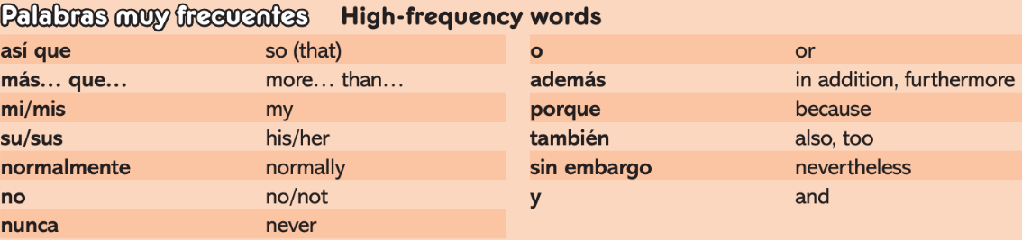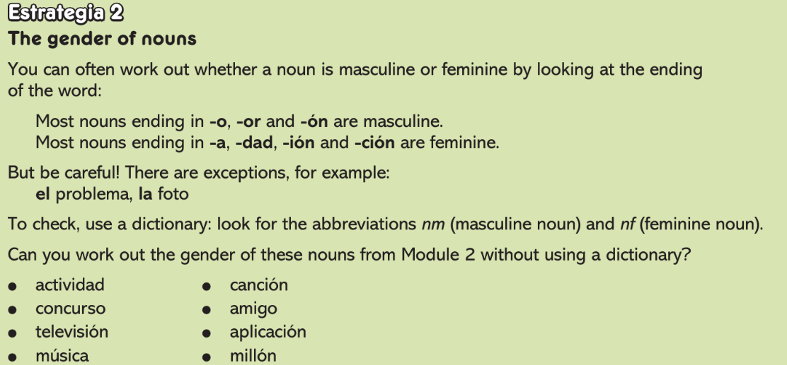

**Module 3 – iA comer! - I can...**

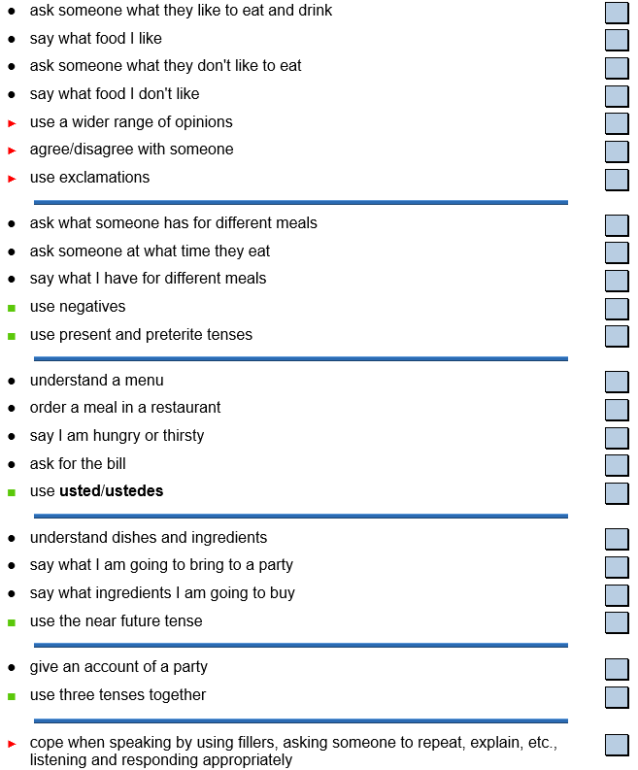

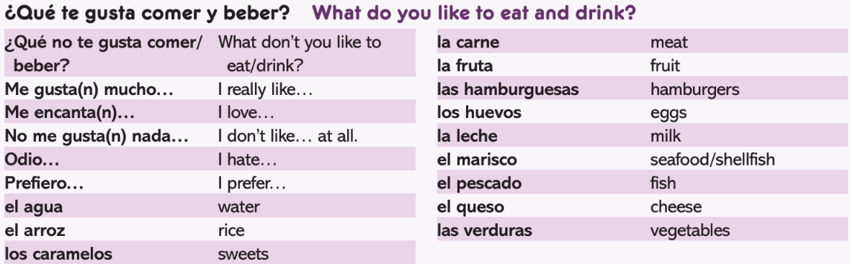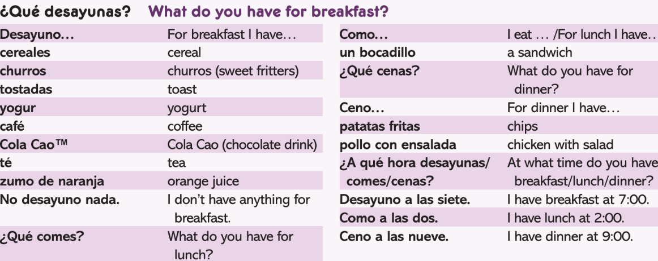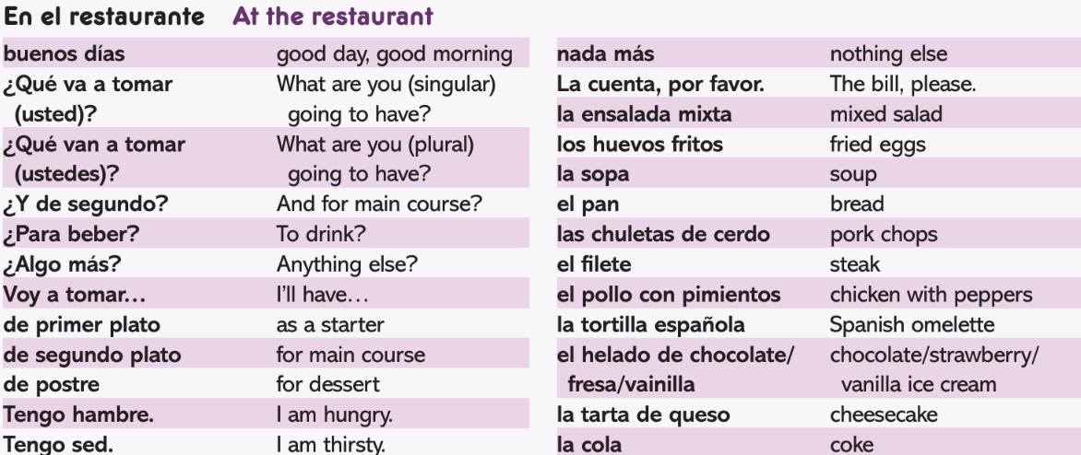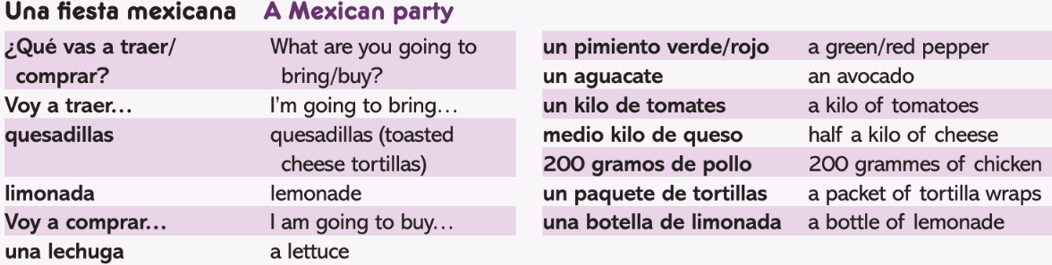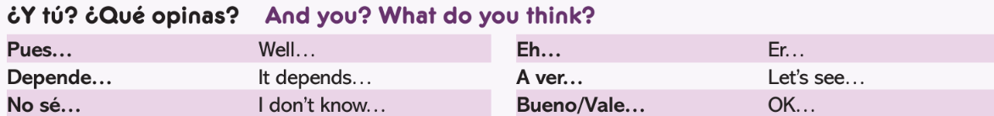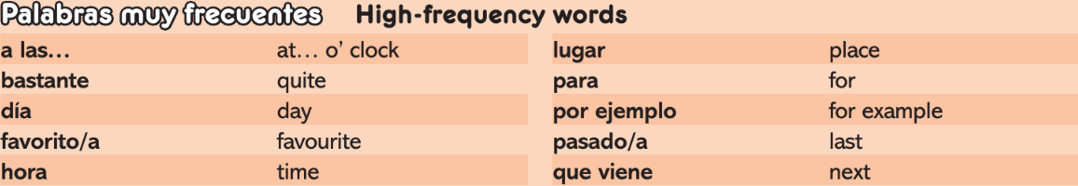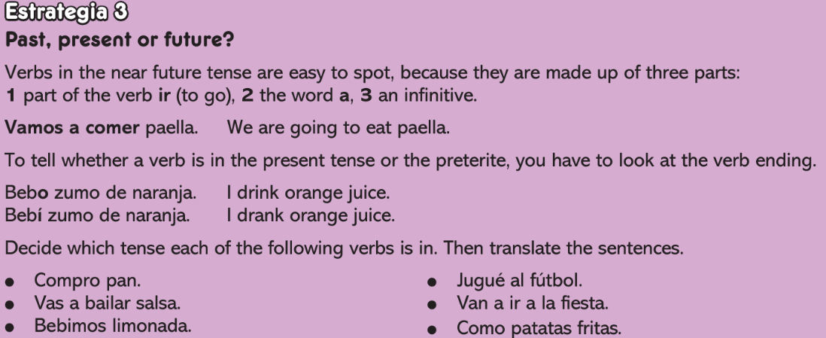

**Module 4 - ¿Qué hacemos? - I can...**

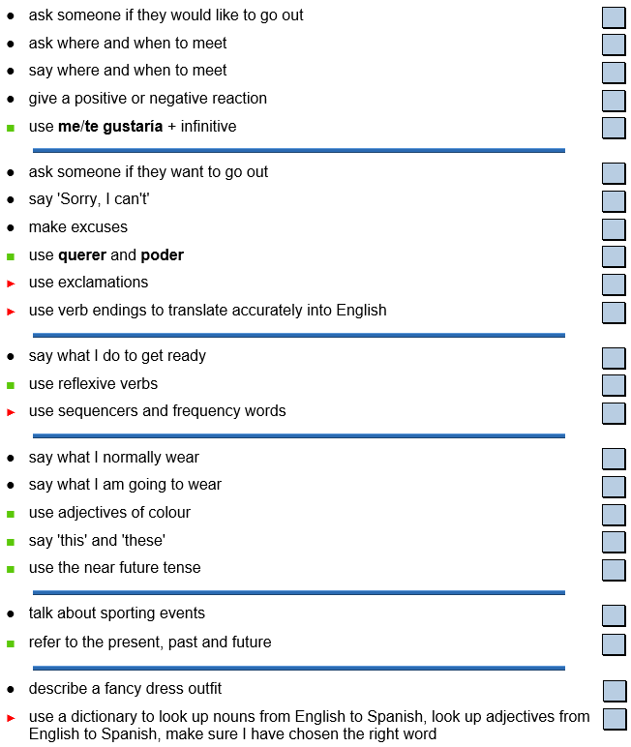

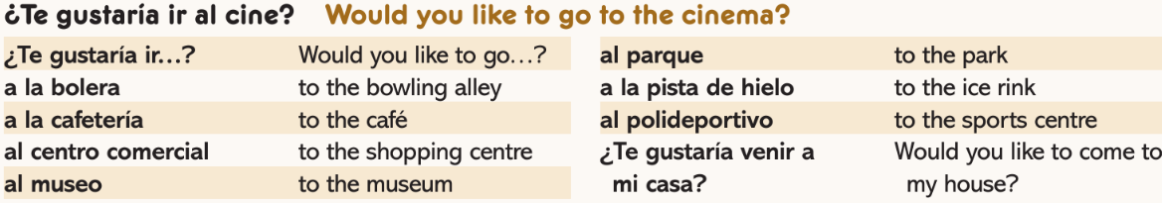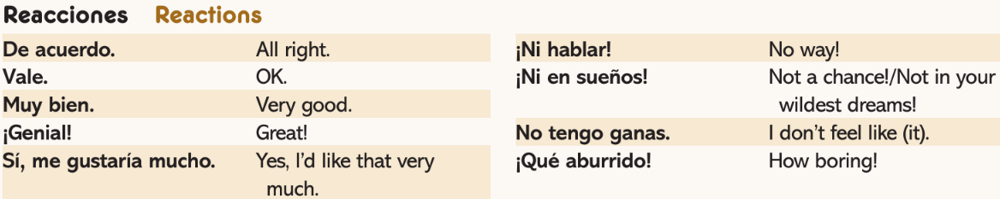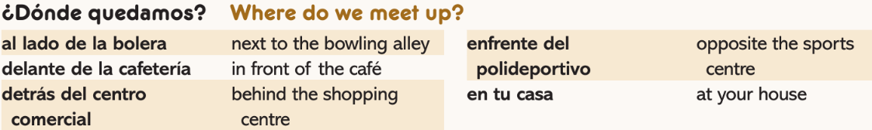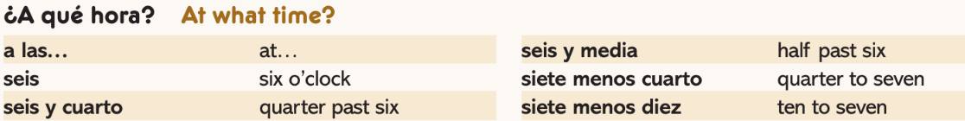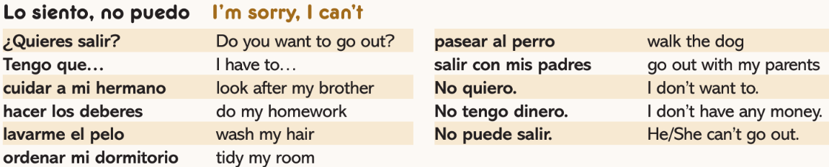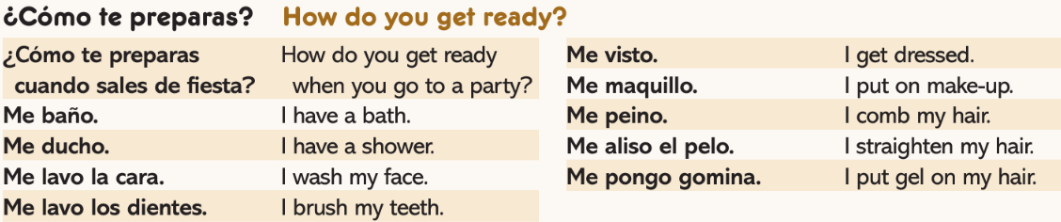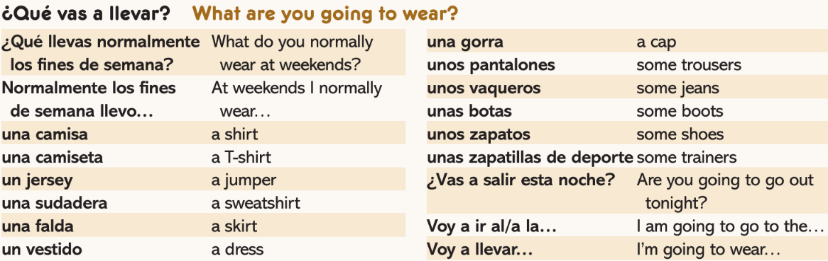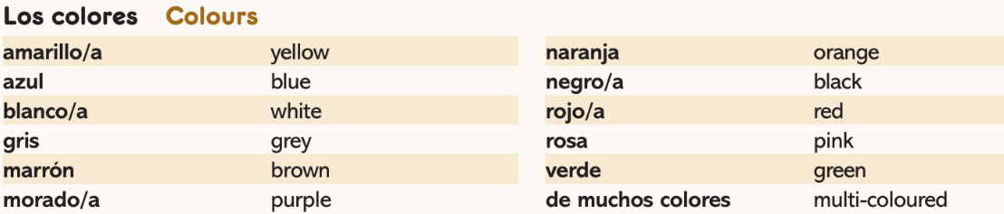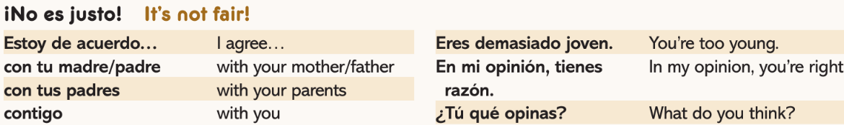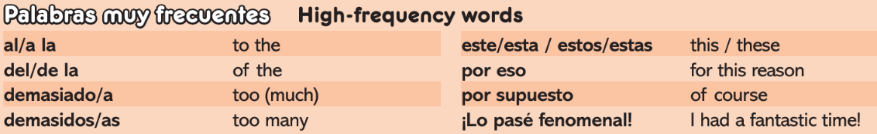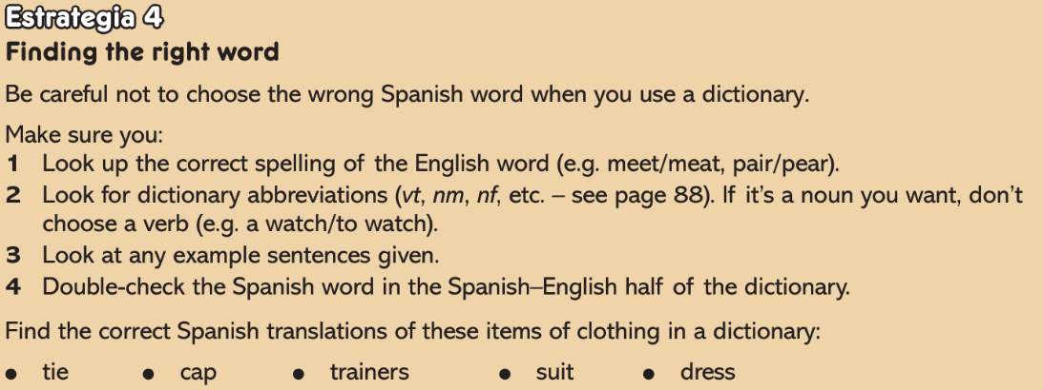

**Module 5 - Operación verano – I can...**

